# Process to take memory dumps

Step1: Unzip and Copy AllscriptsMemoryDumps.zip to C:\

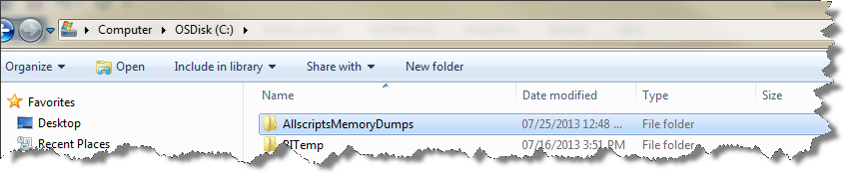

Step2: Run LongRunningCSSJobs.vbs script whenever error occurs

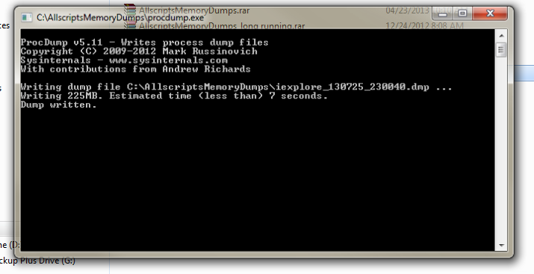

Step3: You will now see memory dump in same folder. Ex iexplore_130725_230011, Applications.CSSWorkerDotNet_160901_101951, etc.

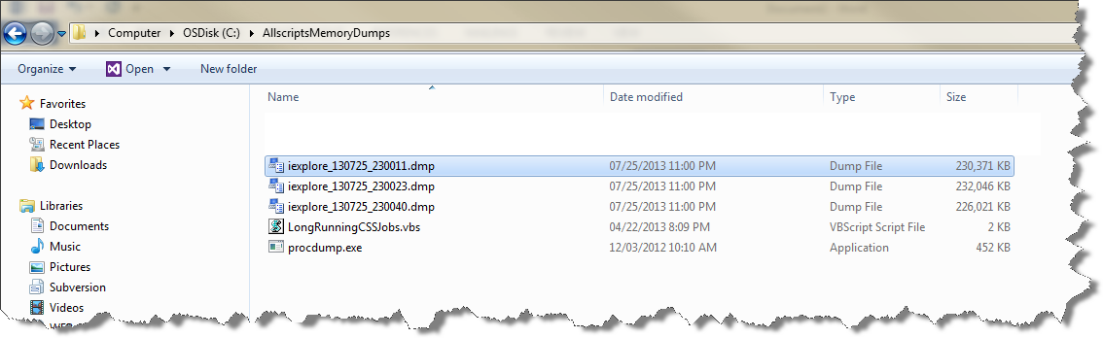

Finally: zip AllscriptsMemoryDumps folder and share the memory dumps with Allscripts.